

CLIENT: | Thelen CDJR | PHONE #:
SPOT: | THEL-CD-T210501 May Freedom Days | FAX # :
LENGTH: | :30 | SALES REP: | Larry H.
DATE: | 5/6/2021 | PRODUCER | A. Dennis

GRAPHICS | Video | AUDIO
Thelen Chrysler Logo  Euclid Ave. - Bay City  www.thelenchryslerjeepdodge.com  (Chrysler, Dodge, Jeep, Ram Logos)  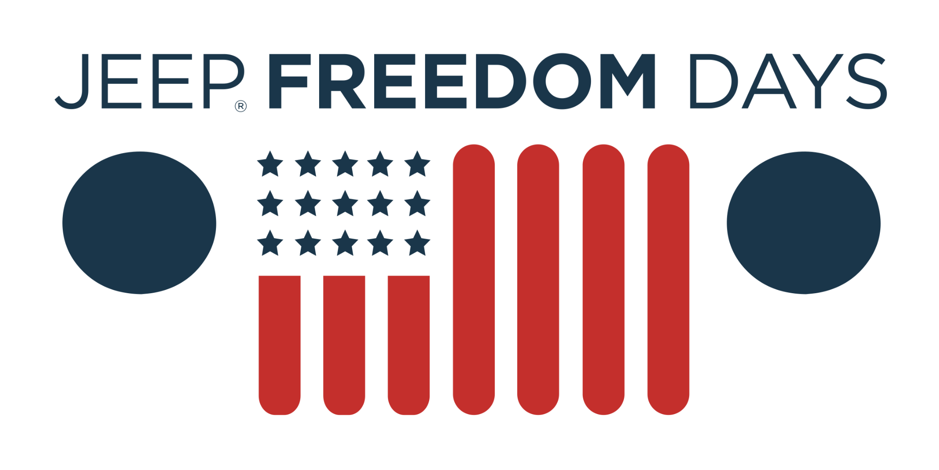  2021 Jeep Renegade Limited  Lease From Just $239/mo  0% APR for 84 Months  0% APR for 84 months equals $11.90 per $1,000 financed, regardless of down payment, for well qualified buyers with approved credit and financing through Chrysler Capital. Not all customers will qualify. Lease for 36 months, 10,000 miles per year with approved credit. $3,382 down or trade equity due at signing. Tax extra. Must qualify for all available rebates and incentives. Picture may not represent the actual vehicle. See Thelen Chrysler for details. Ends 6/1/2021.  2021 Ram 1500 Big Horn Crew Cab  Lease From Just $319/mo  Lease for 36 months, 10,000 miles per year with approved credit. $2,607 down or trade equity due at signing. Tax extra. Must qualify for all available rebates and incentives. Picture may not represent the actual vehicle. Optional equipment shown not included. See Thelen Chrysler for details. Ends 6/1/2021.  Thelen Chrysler Logo  Euclid Ave. - Bay City  www.thelenchryslerjeepdodge.com  (Chrysler, Dodge, Jeep, Ram Logos) | GFX: 2021 Jeep Freedom Days (logo)  GFX: 2021 Jeep Renegade Limited  GFX: 2021 Ram 1500 Big Horn Crew Cab | Announcer: (:30)  Get MORE savings at Thelen Chrysler Dodge Jeep Ram in Bay City!  During Jeep Freedom Days - Thelen Chrysler has the freedom to save you more money!  Because it’s the right thing to do!  Drive a new Jeep Renegade Limited from just $239 a month! Or choose 0% APR for 84 months!  Get more truck for less in a new Ram 1500 Big Horn! Now for just $319 a month!  Only at Thelen Chrysler Dodge Jeep Ram! Euclid avenue, Bay City!  Getting you more for your money... because it’s the right thing to do!

